Week 2
- Write a C program to simulate the following CPU scheduling
algorithm to find turnaround time and waiting time.
a) SJF (Preemptive and Non preemptive)

b) Priority Scheduling (Preemptive and Non preemptive)
Do comparative analysis of all the algorithms by giving data and identify which algorithm is optimal.
a)
#include <stdio.h>
#include <limits.h>

struct Process{
int pid, at, bt, rt;
int ct, tat, wt;
int completed;
};

void calculate(struct Process p[], int n)
{
float avgwt=0,avgtat=0;

printf("\nPID\tAT\tBT\tCT\tTAT\tWT\n");

for(int i=0;i<n;i++)
{
p[i].tat = p[i].ct - p[i].at;
p[i].wt = p[i].tat - p[i].bt;

avgwt += p[i].wt;
avgtat += p[i].tat;

printf("%d\t%d\t%d\t%d\t%d\t%d\n",
p[i].pid,p[i].at,p[i].bt,p[i].ct,p[i].tat,p[i].wt);
}

printf("\nAverage Waiting Time = %.2f\n",avgwt/n);
printf("Average Turnaround Time = %.2f\n",avgtat/n);
}

void reset(struct Process p[], struct Process temp[], int n)
{
for(int i=0;i<n;i++)
{
p[i]=temp[i];
p[i].rt=p[i].bt;
p[i].completed=0;
}
}

void sjf_nonpreemptive(struct Process p[],int n)
{
int time=0,completed=0;

while(completed<n)
{
int idx=-1,min=INT_MAX;

for(int i=0;i<n;i++)
{
if(p[i].at<=time && p[i].completed==0)
{
if(p[i].bt<min)
{
min=p[i].bt;
idx=i;
}
}
}

if(idx!=-1)
{
time+=p[idx].bt;
p[idx].ct=time;
p[idx].completed=1;
completed++;
}
else
time++;
}

printf("\n===== SJF NON PREEMPTIVE =====\n");
calculate(p,n);
}

void sjf_preemptive(struct Process p[],int n)
{
int time=0,completed=0;

while(completed<n)
{
int idx=-1,min=INT_MAX;

for(int i=0;i<n;i++)
{
if(p[i].at<=time && p[i].rt>0)
{
if(p[i].rt<min)
{
min=p[i].rt;
idx=i;
}
}
}

if(idx!=-1)
{
p[idx].rt--;
time++;

if(p[idx].rt==0)
{
p[idx].ct=time;
completed++;
}
}
else
time++;
}

printf("\n===== SJF PREEMPTIVE (SRTF) =====\n");
calculate(p,n);
}

int main()
{
int n;

printf("Enter number of processes: ");
scanf("%d",&n);

struct Process p[n],temp[n];

for(int i=0;i<n;i++)
{
printf("\nProcess %d\n",i+1);

p[i].pid=i+1;

printf("Arrival Time: ");
scanf("%d",&p[i].at);

printf("Burst Time: ");
scanf("%d",&p[i].bt);

p[i].rt=p[i].bt;
p[i].completed=0;

temp[i]=p[i];
}

sjf_nonpreemptive(p,n);
reset(p,temp,n);

sjf_preemptive(p,n);

return 0;
}
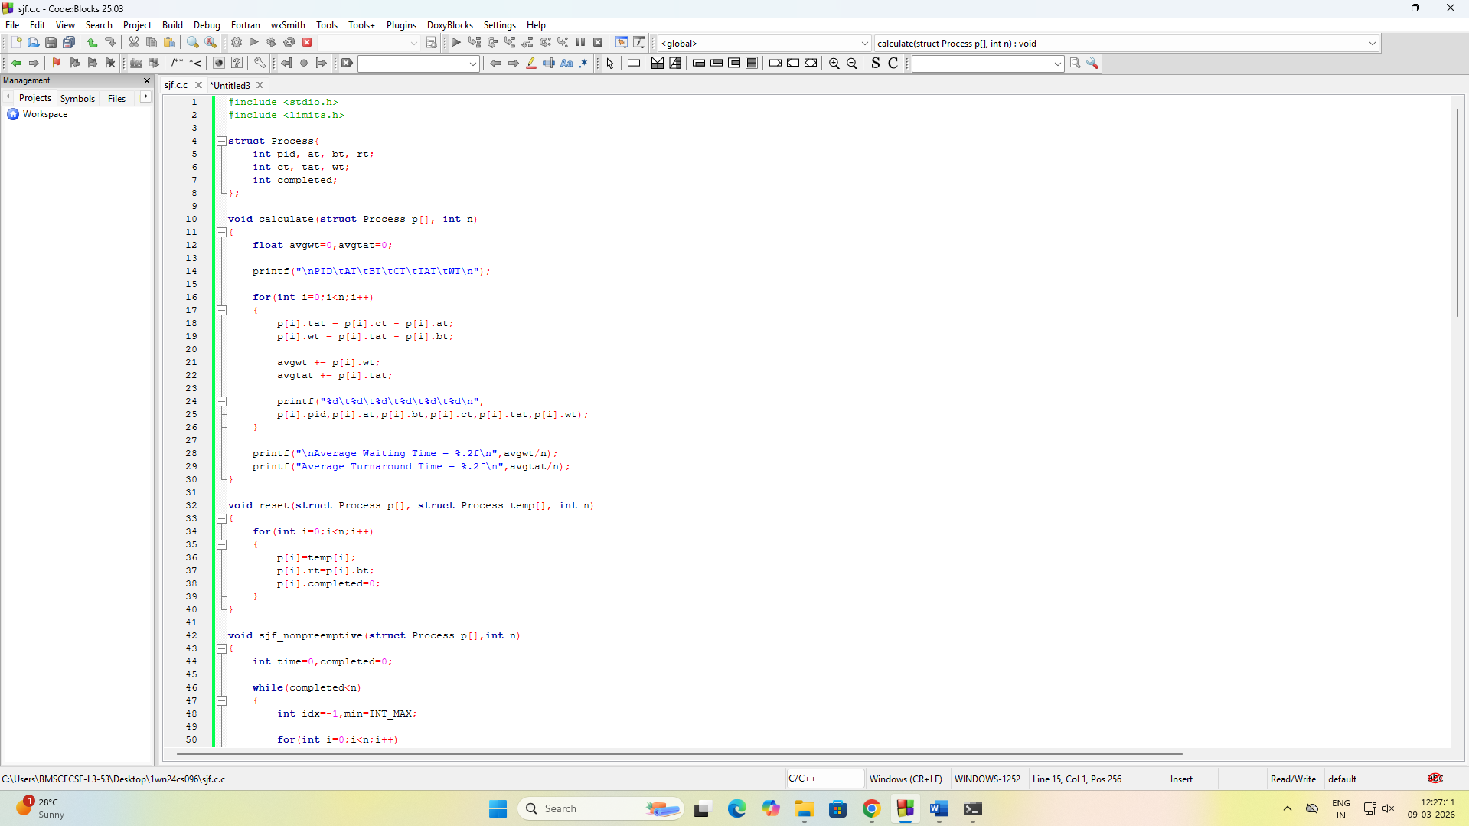

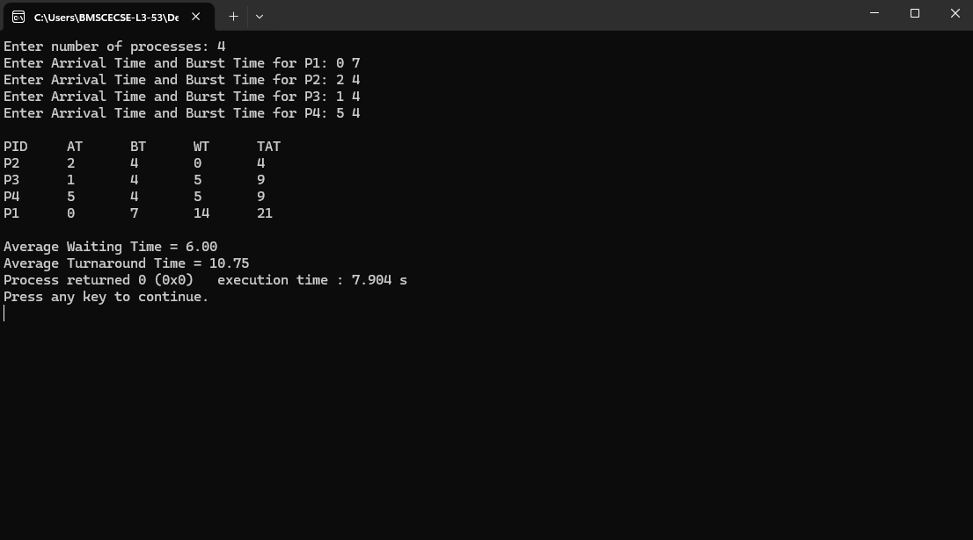

b)
#include <limits.h>
#include <stdio.h>

struct Process
{
int pid, at, bt, pr, rt;
int ct, tat, wt;
int completed;
};

void calculate(struct Process p[], int n)
{
float avgwt = 0, avgtat = 0;

printf("\nPID\tAT\tBT\tPR\tCT\tTAT\tWT\n");

for(int i=0;i<n;i++)
{
p[i].tat = p[i].ct - p[i].at;
p[i].wt = p[i].tat - p[i].bt;

avgwt += p[i].wt;
avgtat += p[i].tat;

printf("%d\t%d\t%d\t%d\t%d\t%d\t%d\n",
p[i].pid,p[i].at,p[i].bt,p[i].pr,p[i].ct,p[i].tat,p[i].wt);
}

printf("\nAverage Waiting Time = %.2f",avgwt/n);
printf("\nAverage Turnaround Time = %.2f\n",avgtat/n);
}

void reset(struct Process p[], struct Process temp[], int n)
{
for(int i=0;i<n;i++)
{
p[i]=temp[i];
p[i].rt=p[i].bt;
p[i].completed=0;
}
}

void priority_nonpreemptive(struct Process p[],int n)
{
int time=0,completed=0;

while(completed<n)
{
int idx=-1;
int high=INT_MAX;

for(int i=0;i<n;i++)
{
if(p[i].at<=time && p[i].completed==0)
{
if(p[i].pr<high)
{
high=p[i].pr;
idx=i;
}
}
}

if(idx!=-1)
{
time+=p[idx].bt;
p[idx].ct=time;
p[idx].completed=1;
completed++;
}
else
time++;
}

printf("\n--- Priority Non Preemptive ---\n");
calculate(p,n);
}

void priority_preemptive(struct Process p[],int n)
{
int time=0,completed=0;

while(completed<n)
{
int idx=-1;
int high=INT_MAX;

for(int i=0;i<n;i++)
{
if(p[i].at<=time && p[i].completed==0)
{
if(p[i].pr<high && p[i].rt>0)
{
high=p[i].pr;
idx=i;
}
}
}

if(idx!=-1)
{
p[idx].rt--;
time++;

if(p[idx].rt==0)
{
p[idx].ct=time;
p[idx].completed=1;
completed++;
}
}
else
time++;
}

printf("\n--- Priority Preemptive ---\n");
calculate(p,n);
}

int main()
{
int n;

printf("Enter number of processes: ");
scanf("%d",&n);

struct Process p[n],temp[n];

for(int i=0;i<n;i++)
{
printf("\nProcess %d\n",i+1);
p[i].pid=i+1;

printf("Arrival Time: ");
scanf("%d",&p[i].at);

printf("Burst Time: ");
scanf("%d",&p[i].bt);

printf("Priority: ");
scanf("%d",&p[i].pr);

p[i].rt=p[i].bt;
p[i].completed=0;

temp[i]=p[i];
}

priority_nonpreemptive(p,n);
reset(p,temp,n);

priority_preemptive(p,n);

return 0;
}
